Standard Energy Usage Numbers for E3TNW

In an effort to standardize baseline values for the various technologies that relate to data centers, the Washington State University (WSU) Energy Program investigated what other researchers were finding. Based on this information, we suggest that the following baseline values be used as “standard” values.

Quantity | Value | Unit | Equiv. Power | Unit | % of Total
Data Center EUI | 1500 | kWh/sf/yr | 171 | avg W/sf | 100%
PUE | 2.6 | NA (ratio) | NA
Data Center HVAC Energy | 810 | kWh/sf/yr | 92 | avg W/sf | 54%
Data Center Computer Loads | 570 | kWh/sf/yr | 65 | avg W/sf | 38%
Data Center UPS Losses | 90 | kWh/sf/yr | 10 | avg W/sf | 6%
Data Center Lighting Energy | 30 | kWh/sf/yr | 3.4 | avg W/sf | 2%

Rationale
Most of the figures were taken from two sources:
- The overall energy use is taken from this Energy Star® presentation (February 2010).
http://www.energystar.gov/ia/partners/prod_development/downloads/DataCenters_GreenGrid02042010.pdf?a238-7f3f .

The data center information in this presentation is based on an analysis of energy usage from 160 data centers of various types – mostly enterprise scale or larger (see slides 18 and 28). On slide 22, the average EUI (Energy Usage index) is shown as approximately 400 kBtu/sf/mo., or about 1,406 kWh/sf/yr.

Because it is difficult to find other reliable numbers and data centers are becoming denser, it seems reasonable to round up overall energy use of a data center to 1,500 kWh/sf/yr.

- The breakdown within a data center was based on the pie chart, below, from this Energy Star training webinar (September 2013).
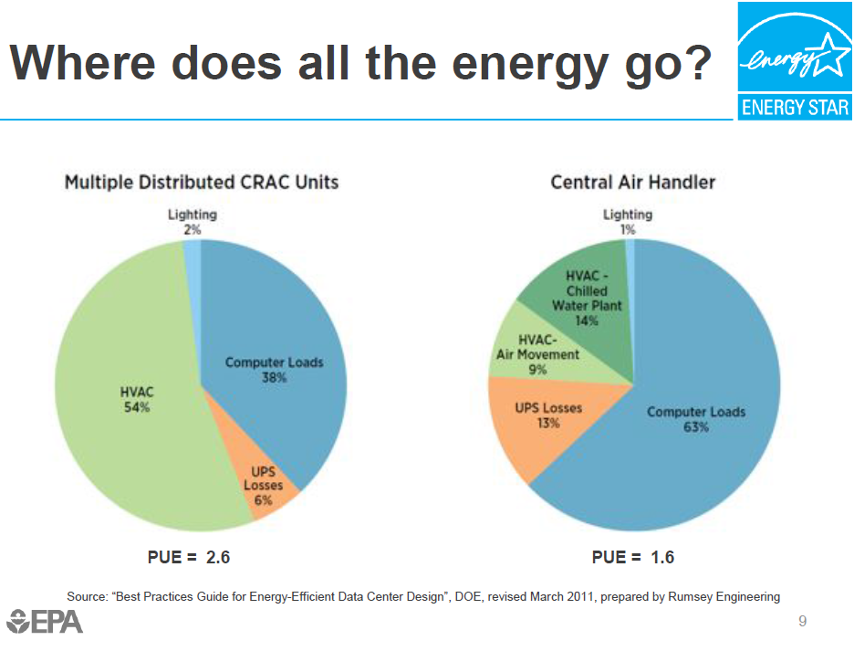

Power Usage Effectiveness (PUE)
BPA is concentrating on small to medium in-building data centers of less than 5,000 sf to about 50,000 sf (not utility-scale data centers of over 100,000 sf). Many practitioners have traditionally used a PUE of 2.0. In the February 2010 Energy Star presentation cited above, a PUE of 1.91 is used (see p. 20).

The Uptime Institute said in 2011, the PUE was 1.8 (http://www.datacenterknowledge.com/archives/2011/05/10/uptime-institute-the-average-pue-is-1-8/), but that appears to be for the large enterprise-level centers.

According to the January 2013 results from a recent Digital Realty Trust survey of selected large companies (greater than $1 billion in annual revenue or more than 5,000 employees) in North America, the average PUE is 2.9 (see p. 19 in
https://na6.salesforce.com/sfc/p/300000005uRq/a/80000000CpC7/k_RJOcsv31zvPC4hgEz9NMQjNd0m4KjS_CzGO5_ni48=). Digital Realty surveyed about 300 data centers, which would be the upper range of our project scope. Because they concentrated on large companies, the data centers are likely relatively large and well-run. If this PUE is 2.9, we could arguably use 3+, but we decided to compromise and use 2.6, making it consistent with the Energy Star chart above. This is higher than the traditional 2.0, but if 2.9 or higher is normal, this gives more conservative savings results for HVAC and other infrastructure measures.

Washington State University Extension Energy Program, 12/6/2013

